1.4 – Solving Equations

Equation: statement with two expressions set equal (has an = sign)
(Ex: 4x = 2)

Solution: a number that yields a true statement when it is substituted for the variable

Properties of Equality (optional… talk about in class-notes if needed)
Addition | If a=b then a+c=b+c | If x=2 then x+3=2+3=5
Addition | If a=b then a+c=b+c | If x = 2, then x + 4 = 6
Subtraction | If a=b then a-c=b-c | If x=2 then x-3=2-3=-1
Subtraction | If a=b then a-c=b-c | If 4y = 10, then 4y – 8 = 2
Multiplication | If a=b then a*c=b*c | If x=2 then 3x=3(2)=6
Multiplication | If a=b then a*c=b*c | If x = 5, then 4x = 20
Division | If a=b then a/c=b/c | If x=2 then x/4=2/4=1/2 (or .5)
Division | If a=b then a/c=b/c | If 4z = 8, then 2z = 4

Examples: Solve each equation, describing the transformation(s) you used to solve each.
a) x – 4 = 5 b) 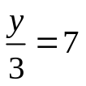

c) 3p = 12 d) 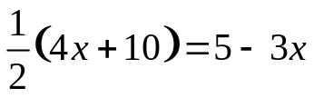

Quick Quiz:
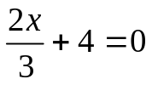 2(x + 2) = 3(x – 8)

Problem Solving:
The bill for the repair of your car was $390. The cost for parts was $215. The cost of labor was $35 per hour. How many hours did the repair work take?

Rewriting Equations with Multiple Variables
1) Determine which variable you want to solve for

2) Isolate terms with desired variable on one side of the equation
(Using the Addition, Subtraction, Multiplication, and Subtraction Properties of Equality)

3) Combine like terms

4) Get variable by itself (no coefficients)

Example:
Solve 7x – 3y = 8 for y

The formula for the perimeter of a rectangle is P = 2l + 2w.
Solve for w.

EXTRA IDEAS IF NEEDED

Problem Solving
Area of a circular ring: A = 2πpw
- Solve for p

- Find p when A = 22 cm² and w = 2 cm

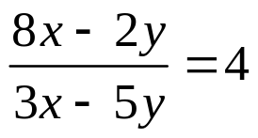; solve when y = 2

Solve for h: 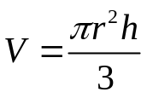

HMWK:
Honors/Regular
pg 30-31 #1-5, 8, 15-21 (odd), 26, 29-30, 33-35 (odd), 47-49 (odd)

